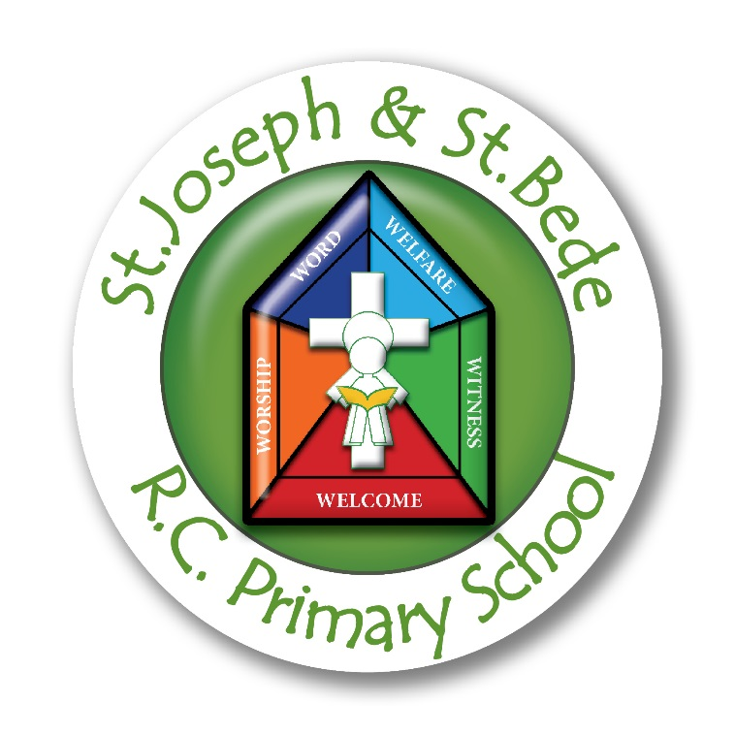

Collective Worship Policy
St Joseph and St Bede RC Primary School



Approved by: | Mrs S. Prince and Governing Board | Date: May 2022
Last reviewed on: | 2022
Next review due by: | March 2025

Our vision
We wish every child to discover their own sense of spirituality and be equipped and able to express it personally and as a part of our faith community.

Mission Statement
Our school is a welcoming, Catholic community, with Christ at the centre.
Through worship, we come together to listen and speak to God, to spread the Gospel message and to move forward in faith together.
As “Guardians of life and creation”; we work together with respect, understanding, honesty and joy, to develop love, tolerance and justice for all.
We strive for greatness in our learning, we develop our unique talents and each day we take pride in all our efforts and achievements.

The Nature of Collective Worship

We believe that Christian worship in a Catholic school is concerned with giving glory, honour, praise and thanks to God. It is our loving response, in word and action, to God’s invitation to enter into relationship, made possible through the work of Jesus Christ and the witness of the Holy Spirit.

Legal Requirements

We acknowledge the legal requirement that there must be a daily act of worship for all pupils. This can take place at any time during the school day and can be either a single act of worship for all pupils, or separate acts of worship in school groups. We acknowledge that collective worship and assembly are distinct activities. They may sometimes form part of the same gathering, but the difference between the two will always be made clear.

The act of worship is not designated curriculum time under regulations and will not be classified under any part of the curriculum, including Religious Education.

The Place of Collective Worship in the Life of our School

We endorse the belief that Collective Worship takes into account the religious and educational needs of all who share in it:
- Those who form part of the worshipping community in church
- Those for whom school may be their first and only experience of church
- Those from other Christian traditions, or none
- Those from other faith backgrounds

It will be an educational activity or experience to which all can contribute and from which all can gain.
Worship in this school is an integral part of school life and central to our Catholic tradition.

The Aims of Collective Worship

We believe that Collective Worship in our school aims to provide opportunity for all pupils and staff:

We believe that Collective Worship in our school will provide a variety of opportunities to deepen our relationships with God and develop the following:-

To contemplate the mystery of God;
To unite our worshipping Eucharistic community;
To develop the necessary skills of:
- reflection
- reverence
- contemplation
- interpretation
- empathy
- meditation
Which will enable our relationships with God to be deepened.

Full participation in our faith will allow us:-
To grow in spiritual, moral, cultural and liturgical understanding;
To grow in understanding of our living faith tradition;
To develop a sense of awe, wonder and inspiration in the person of Christ;
To examine and reflect upon our own individual faith journeys;
To develop the skills of praying in all its differing forms.

Principles

All Acts of Worship in this school will:

- Give glory and honour to God
- Give everyone opportunities for personal reflection
- Be a quality experience, fundamental to the life of the school and its Catholic character
- Give children positive liturgical experiences, appropriate to their age, aptitude and family backgrounds in order to prepare them for the liturgical life of the Church

Daily Prayer in Classes

Each class has its own altar/focal point for collective worship
Morning prayer
Grace before meals
Grace after meals/meditation/reflection
Prayers at the end of the day

Class Liturgies

EYFS and KS1 teachers provide opportunities each week for children to have their own worship within the class.
KS2 children are greatly encouraged and taught to prepare and lead their own class worship each week. They are based upon the Liturgical Year, the RE topic, current events and the Sacramental Programme.
The GIFT Team prepare the scripture and prayers for whole school assembly on a Friday. Whole school liturgies and worships are prepared and lead by the pupils, supported by the GIFT Team.
The Croi is used by all classes on a regular basis for periods of reflection and class worship.
Classes have their own selection of prayer and scripture based books.
Ten:Ten resources available for daily class worship.

Monday | Tuesday | Wednesday | Thursday | Friday
Good News Assembly | Assembly (EYFS and KS1) | Assembly (KS2)  *EYFS & KS1 Singing Worship | KS2 Singing Worship | Celebration Assembly

Collective Worship in class must take place on days that is no assembly. Singing Worship (Hymns) is included in daily acts of Worship and in a set assembly on Wednesday and Thursday.

Celebration of the Eucharist

We believe that The Mass is the ultimate expression of our existence as a faith community. It therefore it takes a central place in school life.
We celebrate Mass regularly with parents and parishioners.
We have whole school Masses throughout the school year, celebrating different Feast Days and Holy Days. We gather together in church for St Joseph’s Day.
Pupils take a fully active part in preparation, reading and serving.

Sacrament of Reconciliation

During Advent and Lent an emphasis is placed upon the Sacrament of Reconciliation. The KS2 classes have the opportunity to prepare their own act of worship which includes the opportunity to attend Reconciliation.
In EYFS and KS1 the children have more informal time in class to reflect and say sorry to God.

Advent

A highly successful Advent worship has taken place for many years. Its aim is to provide a focus on the importance of getting ready for the Birth of Christ. The worship is a visual, musical experience and has been designed to involve each class in an intimate setting. Each class in UKS2 prepares a reflection and parents are invited in to participate in the collective worship. Afterwards they are invited to stay for coffee and mince pies. This is very well attended and parents have had a positive response to these Advent services.

We prepare for the season of Advent by ‘going purple’ across the whole school.
The Travelling Crib is sent home with a different family each day during Advent and into January. The aim is to bring parents closer to the faith life of the school and the Church. The children complete a prayer diary which might include a painting or drawing, a prayer or a photograph.

Lent

A Mass or worship marking the Stations of the Cross is attended by the whole school. Each class or the GIFT Team prepares a different station and children reflect on the station, often followed with an action. This is alternated with a Scavenger Hunt ending in a worship around the outdoor cross. Members from the GIFT Team support and lead these stations. Holy Week celebrations are an integral part of our school celebration and prayer life. Lenten prayer bags are sent home to mark this special time of year, these include Cuddly Jesus, Story Spoons, prayers and reflections and different books based on the Easter story.
Pentecost

Pentecost is a whole school celebration where we encourage children to reflect on and celebrate the birth of the Church. We involve the whole community in a variety of ways, for example a Pentecost Parade or a Pentecost Party. There is always a worship to celebrate this time of year.

The Planning, Content and Delivery of Collective Worship

Collective Worship is planned:
- To develop in pupils skills that enable them to prepare, organise and lead worship rather than always participating or contributing in a token way.
- To be spontaneous and meaningful. Emphasis is on active participation.
- With flexibility to respond to changing situations within the school and the wider community

The format for Collective Worship for our school will be:
- We Gather – how we come together, the setting, the environment (quiet reflective music, lighted candles, icons etc.)
- We Listen – every worship will centre around at least one text from the Bible or a piece of Scripture
- We Respond – The response to the Word may lead into a time of ritual action or communal prayer. The ritual action may vary (dance, music, drama, art, poetry etc.) We place our needs before God (prayers of intercession.)
- We Go Forth – Giving the children something to hold on to from the experience of the liturgy that they can take into their daily lives.

Progression in Worship

The progression of Collective Worship is carefully considered and throughout the school and builds on from children’s prior experiences.

EYFS | Year 1 | Year 2 | Year 3 | Year 4 | UKS2
Listen to scripture  Take part in circle prayer with a prompt  Participate in short periods of silence | Lay out altar with help  Listen to scripture  Take part in circle prayer with a prompt  Participate in short periods of silence. | Lay out altar  Read scripture  Make up own circle prayer  Increasing comfort with periods of silence | Lay out altar with some guidance.  Select theme for scripture  Respond to a psalm.  Make own circle prayer and use symbols.  Spend time in silence. | Set up altar independently  Prepare reading and psalm (help may be given)  Improvise circle prayer.  Select prayers for use  Using ICT, select images to be used for reflection. | Set up altar independently, being increasingly creative.  Select reading and prayers from a variety of sources( Bible, books, workbooks, web etc.)  Compose prayers in different styles to match given needs.  Prayers become increasingly detailed in what they are asking for, the reasons why and what they want the outcome to be.  Create ICT aids (e.g. PowerPoints/photo story)  Search for visual aids( ego from a bank of YouTube videos / Google image/CADOD resources)  Match prayers and readings with a given theme.  Invent own symbolic actions.  Spend increasing amounts of time in silence.

Recording

Collective Worship is recorded:

- Through displays, collections of pupils’ contributions, prayers, reflections, photographs, videos etc
- In Floor Books or Wonder and Awe books
- Through class Twitter and SeeSaw

Monitoring and Evaluation

At least once a year the school’s provision of worship will be evaluated to consider whether it meets the needs of all pupils and whether pupils are making progress in acquiring skills and abilities in organising and leading worship. Feedback is shared with staff.

Resources

Each class has its own collection of Worship resources. A main supply is maintained by the RE coordinator and is available at all times.

Policy Monitoring and Review

This policy is monitored by the RE Lead and Headteacher and is evaluated and reviewed by the whole school staff and governors every year.

S. Prince May 2023

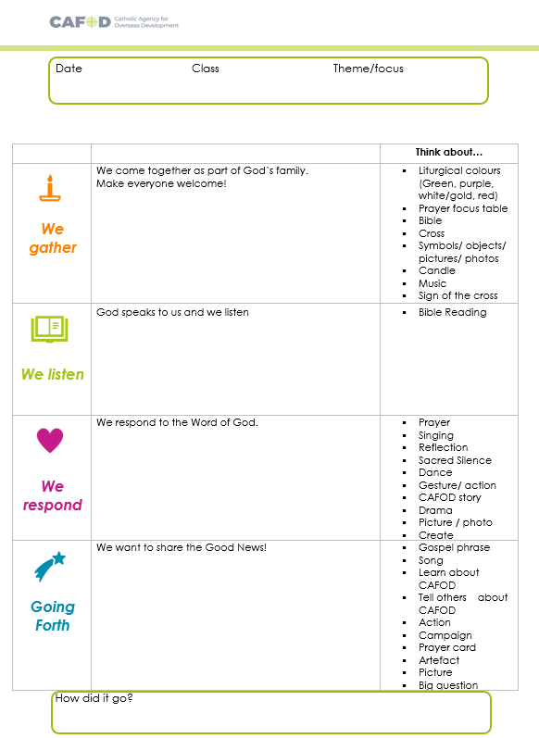
Appendix 1

